SIMATS ENGINEERING
ASSESSMENT TOOL
COURSE NAME: Theory of Computation COURSE CODE: CSA13

COURSE OUTCOME COVERED
CO1: Analyze fundamental mathematical concepts of automata theory for formal languages and decision problems.(BL:3)
Assessment Tool Weightage: 40%

QUESTIONS: 5 Total Marks:25 Duration : 1 Hour

Analytical Problem

Code of Conduct:
I Aryan Arun (192411157) certify that this submission is my original work and that I have adhered to the guidelines specified for this assessment.
I understand that any violation of academic integrity rules will result in disciplinary action. Signature of the student:

SIMATS ENGINEERING
ASSESSMENT TOOL
1.Consider the NFA given below which accepts some language L over the alphabet ��={a,b}. Construct a DFA that represents the same language L
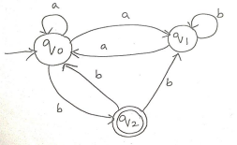
2.Let L be the language of words of length atleast 2 whose last two letters are difference from each other. For example abaab is in L but not bb, Construct an NFA for L, Then draw the equivalent DFA
3. Design a Nondeterministic Finite Automata (NFA) that takes a binary string as input and accepts the string only if the last two digits are the same (either 00 or 11). Write the formal definition of the NFA. Also show that the string 01011 is accepted by the NFA
4. Consider the NFA given below which accepts the language representing the set of all strings having 001 as a substring over the alphabet ��={0,1}. Construct a DFA that represents the same language.
5. A NFA with ε-transitions is given below. Find ε-closure for each state and Design an equivalent DFA which accepts the same language. Draw its transition table and mark the initial and final

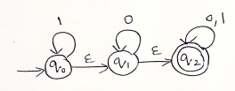
SIMATS ENGINEERING
ASSESSMENT TOOL
RUBRICS FOR CALCULATION
Criteria | Weightage | Level 4 –  Exemplary (5 Marks) | Level 3 –  Proficient (4 Marks) | Level 2 –  Developing (2–3 Marks) | Level 1 –  Beginning (0–1 Mark)
Conceptual  Understanding | 30 | Demonstrates clear and complete  understanding of the concept | Good  understanding with minor gaps | Basic  understanding with some  misconceptions | Poor or  incorrect  understanding
Accuracy of Answer | 25 | Completely correct answer with no errors | Mostly correct with minor  errors | Partially correct with noticeable errors | Incorrect or  irrelevant  answer
Application of Knowledge | 20 | Correctly applies concepts to solve the  question/problem | Applies  concepts with minor mistakes | Limited or partially correct application | No or incorrect application
Completeness of Response | 15 | Covers all required parts of the  question | Covers most parts with minor omissions | Covers only some parts | Incomplete or missing  response

1. Convert the given NFA into an equivalent DFA
Alphabet: Σ = {a, b}. Initial state: q₀. Final state: q₂.
Reading the transitions from the given diagram, the NFA transition table is:
State | Input a | Input b
→ q₀ | {q₀, q₁} | {q₂}
q₁ | {q₀} | {q₁}
* q₂ | ∅ | {q₀, q₁}

Subset construction. Start with A = {q₀} and compute the move on a and b for every new subset:
• A = {q₀}: on a → {q₀, q₁} = B; on b → {q₂} = C
• B = {q₀, q₁}: on a → {q₀, q₁} ∪ {q₀} = {q₀, q₁} = B; on b → {q₂} ∪ {q₁} = {q₁, q₂} = D
• C = {q₂}: on a → ∅ = E; on b → {q₀, q₁} = B
• D = {q₁, q₂}: on a → {q₀} ∪ ∅ = {q₀} = A; on b → {q₁} ∪ {q₀, q₁} = {q₀, q₁} = B
• E = ∅: on a → ∅ = E; on b → ∅ = E (dead state)
DFA transition table:
DFA state | a | b
→ A = {q₀} | B | C
B = {q₀, q₁} | B | D
* C = {q₂} | E | B
* D = {q₁, q₂} | A | B
E = ∅ | E | E

Initial state: A. Final states: C and D (the subsets that contain q₂). No new subsets appear, so the construction is complete.
DFA DIAGRAM:
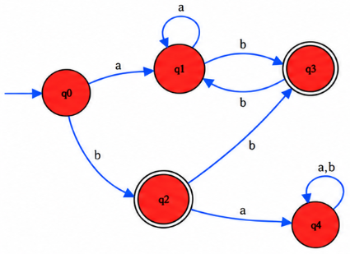

2. NFA for strings of length at least 2 whose last two letters are different
Language: L = {w ∈ {a, b}* : |w| ≥ 2 and the last two symbols of w are different}, i.e. all strings that end in ab or ba.
NFA design. State q₀ (start) loops on a and b so that any prefix can be read. The NFA then guesses the second-last symbol: on a it may move to q₁ and must then read b to reach q_f; on b it may move to q₂ and must then read a to reach q_f. q_f is the only final state and has no outgoing transitions, so acceptance happens only when the guessed pair is the last two symbols.
Formal definition: M = (Q, Σ, δ, q₀, F) with Q = {q₀, q₁, q₂, q_f}, Σ = {a, b}, F = {q_f}.
State | Input a | Input b
→ q₀ | {q₀, q₁} | {q₀, q₂}
q₁ | ∅ | {q_f}
q₂ | {q_f} | ∅
* q_f | ∅ | ∅

NFA DIAGRAM:
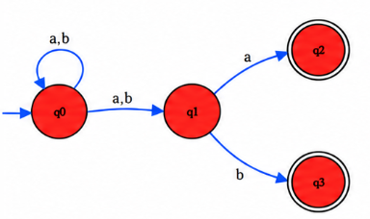
Equivalent DFA (subset construction). Starting from A = {q₀}:
• A = {q₀}: a → {q₀, q₁} = B; b → {q₀, q₂} = C
• B = {q₀, q₁}: a → {q₀, q₁} = B; b → {q₀, q₂, q_f} = E
• C = {q₀, q₂}: a → {q₀, q₁, q_f} = F; b → {q₀, q₂} = C
• E = {q₀, q₂, q_f}: a → {q₀, q₁, q_f} = F; b → {q₀, q₂} = C
• F = {q₀, q₁, q_f}: a → {q₀, q₁} = B; b → {q₀, q₂, q_f} = E
DFA state | a | b
→ A = {q₀} | B | C
B = {q₀, q₁} | B | E
C = {q₀, q₂} | F | C
* E = {q₀, q₂, q_f} | F | C
* F = {q₀, q₁, q_f} | B | E

The reachable DFA states are A, B, C, E and F. The accepting states are E and F because they contain q_f.
Check: abaab → A –a→ B –b→ E –a→ F –a→ B –b→ E (accepted). bb → A –b→ C –b→ C (rejected).
DFA DIAGRAM:
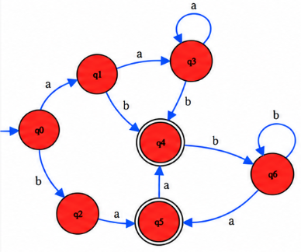

3. NFA that accepts binary strings whose last two digits are equal
Alphabet: Σ = {0, 1}. The language is the set of all binary strings that end in 00 or 11.
Design. q₀ loops on 0 and 1 to skip any prefix. On a 0 it may guess that the final pair has begun (q₀ → q₁), and q₁ must read another 0 to reach q_f. Similarly on a 1 it may move q₀ → q₂, and q₂ must read another 1 to reach q_f.
Formal definition: N = (Q, Σ, δ, q₀, F) where
• Q = {q₀, q₁, q₂, q_f}
• Σ = {0, 1}
• q₀ is the start state
• F = {q_f}
• δ is given by the table below
State | Input 0 | Input 1
→ q₀ | {q₀, q₁} | {q₀, q₂}
q₁ | {q_f} | ∅
q₂ | ∅ | {q_f}
* q_f | ∅ | ∅

NFA DIAGRAM:
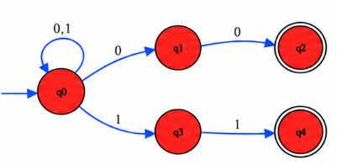
Acceptance of 01011. One accepting computation path is:
q₀ –0→ q₀ –1→ q₀ –0→ q₀ –1→ q₂ –1→ q_f
The NFA stays in q₀ for the first three symbols 0, 1, 0, then guesses that the last two symbols have begun: reading 1 moves q₀ → q₂, and reading the final 1 moves q₂ → q_f. The whole input is consumed and q_f ∈ F, so 01011 is ACCEPTED (it ends in 11).

4. DFA for all strings over {0,1} having 001 as a substring
Alphabet: Σ = {0, 1}. The NFA diagram for this question is not shown in the question paper, so the standard NFA for "contains 001" is used: q₀ loops on 0,1; q₀ –0→ q₁ –0→ q₂ –1→ q₃; q₃ loops on 0,1. Start state q₀, final state q₃.
State | Input 0 | Input 1
→ q₀ | {q₀, q₁} | {q₀}
q₁ | {q₂} | ∅
q₂ | ∅ | {q₃}
* q₃ | {q₃} | {q₃}

NFA DIAGRAM:
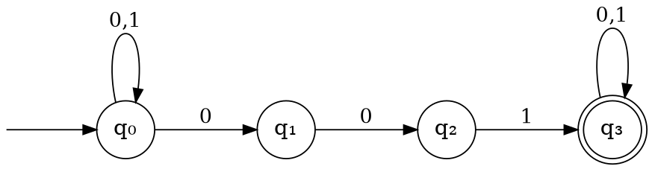
Subset construction.
DFA state | Input 0 | Input 1
→ A = {q₀} | B | A
B = {q₀, q₁} | C | A
C = {q₀, q₁, q₂} | C | D
* D = {q₀, q₃} | E | D
* E = {q₀, q₁, q₃} | F | D
* F = {q₀, q₁, q₂, q₃} | F | D

Initial state: A. Final states: D, E, F (subsets containing q₃).
DFA DIAGRAM (subset construction):
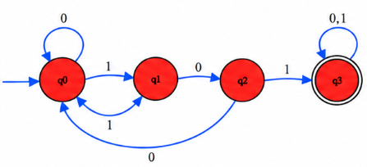

5. ε-closures and equivalent DFA
From the given ε-NFA: q₀ has a loop on 1; q₀ –ε→ q₁; q₁ has a loop on 0; q₁ –ε→ q₂; q₂ has loops on 0 and 1 and is the final state.
ε-closures:
• ε-closure(q₀) = {q₀, q₁, q₂}
• ε-closure(q₁) = {q₁, q₂}
• ε-closure(q₂) = {q₂}
Subset construction. The DFA start state is ε-closure(q₀) = {q₀, q₁, q₂} = A.
• A on 0: δ(q₀,0) ∪ δ(q₁,0) ∪ δ(q₂,0) = ∅ ∪ {q₁} ∪ {q₂} = {q₁, q₂}; its ε-closure is {q₁, q₂} = B
• A on 1: {q₀} ∪ ∅ ∪ {q₂} = {q₀, q₂}; its ε-closure is {q₀, q₁, q₂} = A
• B on 0: {q₁} ∪ {q₂} = {q₁, q₂} = B
• B on 1: ∅ ∪ {q₂} = {q₂}; its ε-closure is {q₂} = C
• C on 0: {q₂} = C; C on 1: {q₂} = C
Transition table:
DFA state / subset | Input 0 | Input 1 | Final?
→ A = {q₀, q₁, q₂} | B | A | Yes
* B = {q₁, q₂} | B | C | Yes
* C = {q₂} | C | C | Yes

Initial state: A. Final states: A, B and C, because each subset contains q₂, the final state of the ε-NFA. Since q₂ is reachable from q₀ using only ε-moves, every input string (including ε) is accepted.
DFA DIAGRAM:
